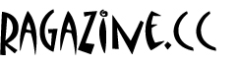
May-June 2013 – The On-Line Magazine of Art, Information & Entertainment – Volume 9, Number 3
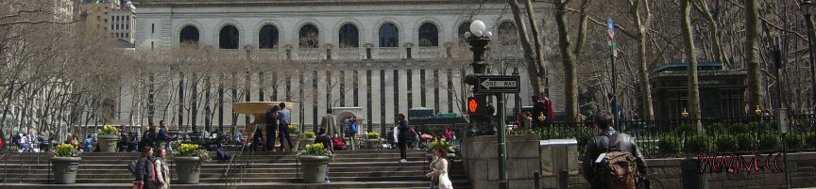

News, Haps & Snaps

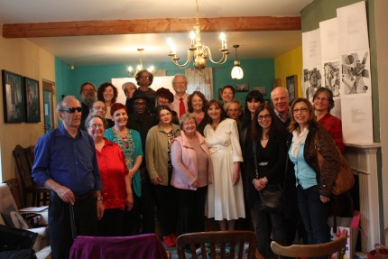
The poets and presenters; photo by Christian Moraru, Toronto, Canada
Art by Edmon Khalil from Sudan, living now in Sweden.

PALABRA EN EL MUNDO Revisited
By Flavia Cosma
The Seventh International Writers’ and Artists’ Festival at Val-David, Quebec Canada, “Palabra en el mundo” (Words in the World) came to an end on May 26th 2013 in the presence of distinguished artists, poets and writers from all over the world. The Festival is organized biannually by The International Writers’ and Artists’ Residency, Val-David, QC, Canada, and took place 25 and 26 May, 2013
The prestigious event counts with the support of the Council of Arts, Canada, the League of Canadian Poets, the Municipality of Val-David and the Association des Auteurs des Laurentides. As the Director of this Festival and a poet and cultural promoter myself, I consider that poetry has its own life, its own music and that one can enjoy poetry even in a different language, and even when one doesn’t speak the language in which we listen to it.
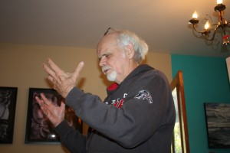
Charles Hayes, USA. Photo by Christian Moraru, Toronto, Ontario, Canada.
Moreover we live here in Canada in a society totally multilingual, with immigrants who came her from around the world searching for a better life. But as anyone knows, the economical aspect is never enough. We have to find ways to express our spiritual and artistic aspirations and talents, and the Festival was a good answer for many writers and artists who have been born in another country and were feeling like foreigners in this wonderful country of ours.
From the very beginning the Festival started developing in an incredible manner. A combination of poetry, visual arts and other artistically expressions weaved themselves together as a natural extension. The Seventh Festival was the best festival ever for the quality of the presentations and as well as for the participation of a numerous public at large. We counted with the presence of writers and artists of an excellent level from Canada and from abroad as well as contemporary international artists of an incredible quality of expression.
It was like an immersion in a never ending fairy tale of poetry, stories and art works that although very different one from another, were harmonizing together extraordinarily. After the Festival the reaction of the participants and of the public was very encouraging. I’ll cite one comment at random:
For me as a poet the Festival at Val-David was a wonderful occasion to meet the other poets and artists from all over the world, to see and listen to their work and their reflections on poetry. What a variety of people there were: a true United Nations of artists. (Hugh Hazelton, poet, Montreal).
Very educational, professional and much appreciated by the public were the two Sunday morning conferences (May 26, 2013):
- Alan Britt, USA, “On modern tendencies in American poetry”
- Patricia Tenorio, Brazil, “ On Ekphrasis (the verbal representation of a visual representation) in poetry, particularly in Brazilian poetry”
The Eighth International Writers’ Festival Lyrical Wild Berries Harvest, a multilingual Poetry and Prose reading and Art Exhibition will take place on October 5th and October 6th, 2013. For more info and possible participations please write flaviacosma@rogers.com, and/or visit www.flaviacosma.com.
* * * * *

